Project Two

Paige Marinkov
CS 340 Client Server Development
Southern New Hampshire University
Professor Scranton
April 19, 2026

About the Project
This project is a web-based dashboard application developed using Python, MongoDB, and the Dash framework. The purpose of the dashboard is to allow Grazioso Salvare to interact with and visualize animal shelter data from the Austin Animal Center Outcomes dataset.
The dashboard provides an intuitive interface that enables users to filter, view, and analyze animal rescue data in real time. It follows the Model-View-Controller (MVC) design pattern, where MongoDB serves as the data model, Dash components act as the view, and the CRUD Python module functions as the controller.
Project Functionality
The dashboard includes the following key features:
- Interactive Filtering Options
- Users can filter data based on rescue categories:
- Water Rescue
- Mountain or Wilderness Rescue
- Disaster or Individual Tracking
- Reset (returns to all data)
- Interactive Data Table
- Displays animal records from MongoDB and dynamically updates based on selected filters.
- Data Visualization (Charts)
- A pie chart displays the distribution of animal breeds based on filtered data.
- Geolocation Map
- Displays the selected animal’s location using latitude and longitude coordinates.
- Dynamic Updates
- All components (table, chart, and map) update automatically when a filter is applied.
- Unique Identifier
- The dashboard includes my name as a unique identifier for submission verification.

Figure 1: Default Dashboard (All Data)
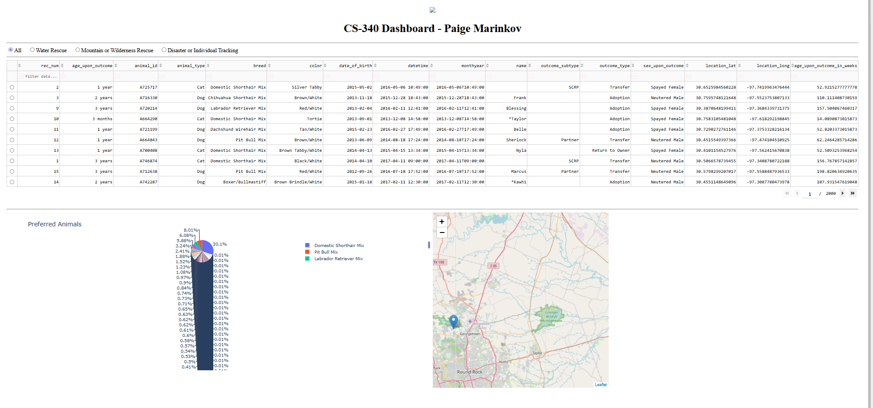
Figure 2: Water Rescue Filter Applied
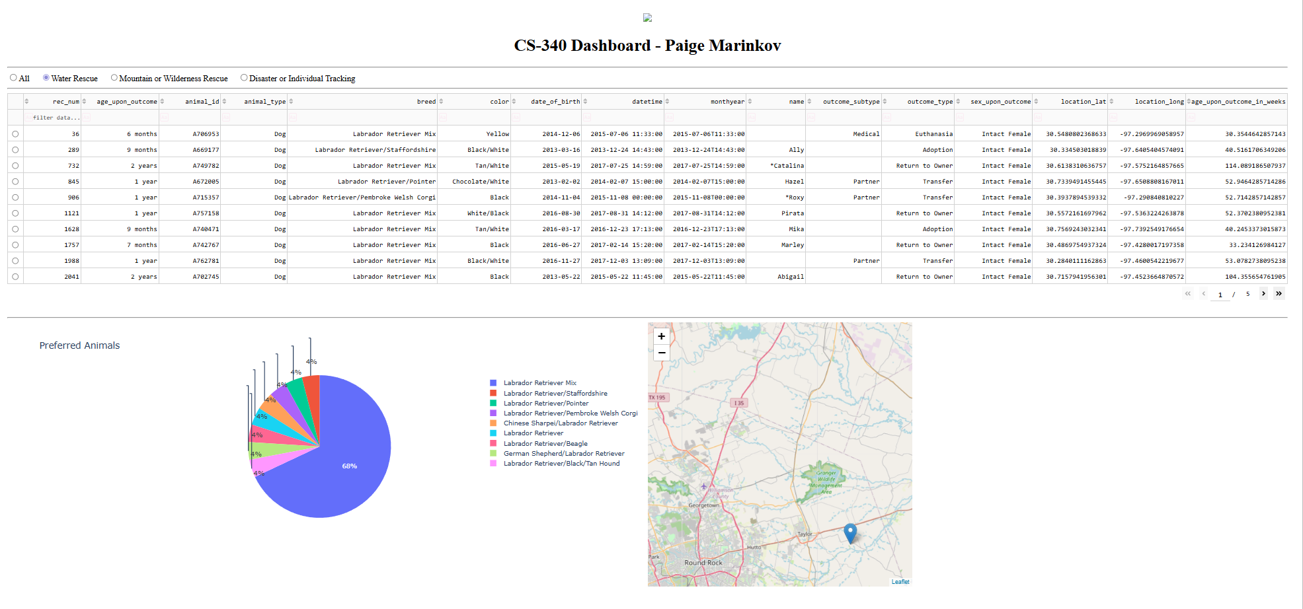

Figure 3: Mountain or Wilderness Rescue Filter Applied
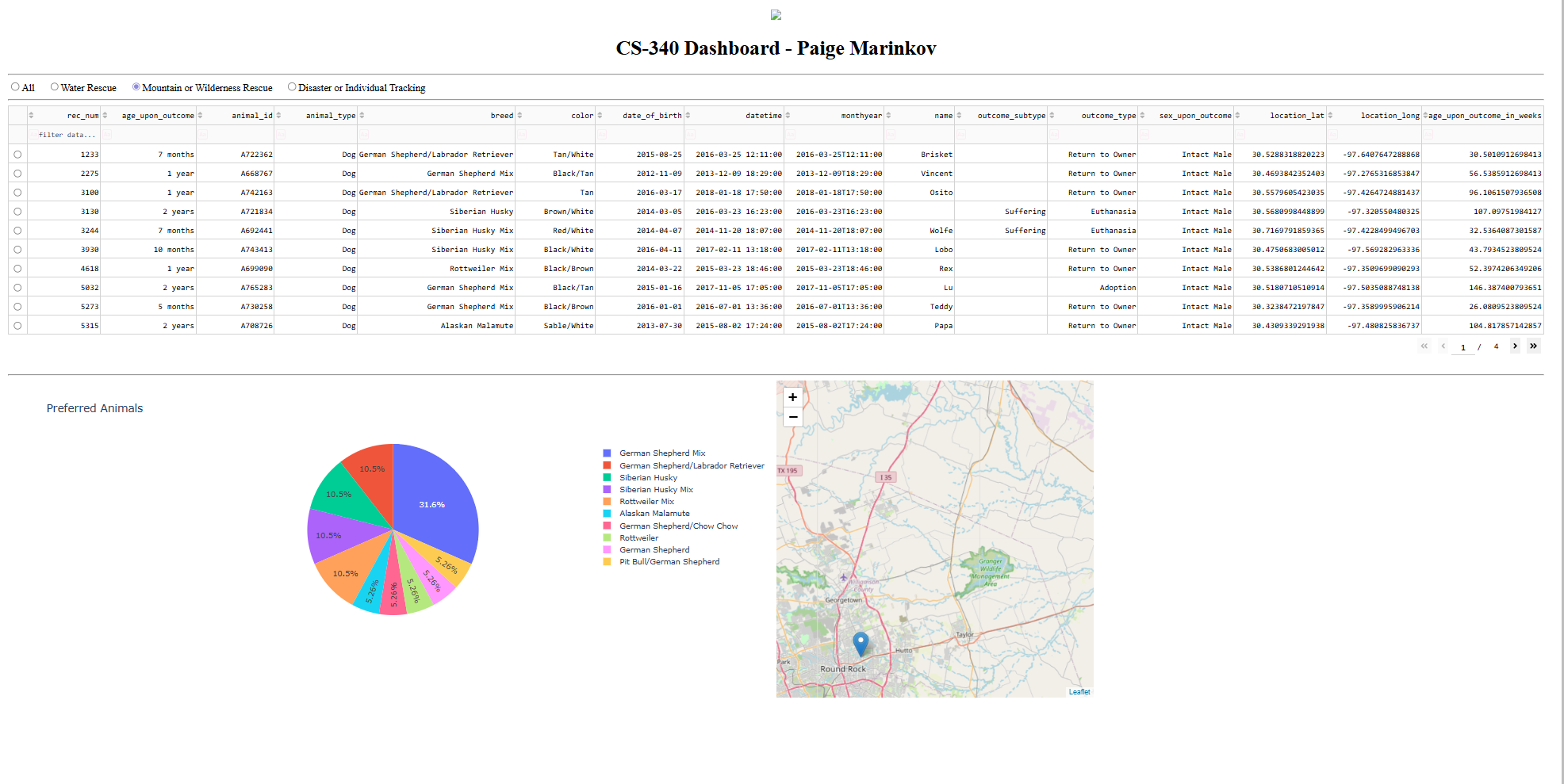
Figure 4: Disaster or Individual Tracking Filter Applied
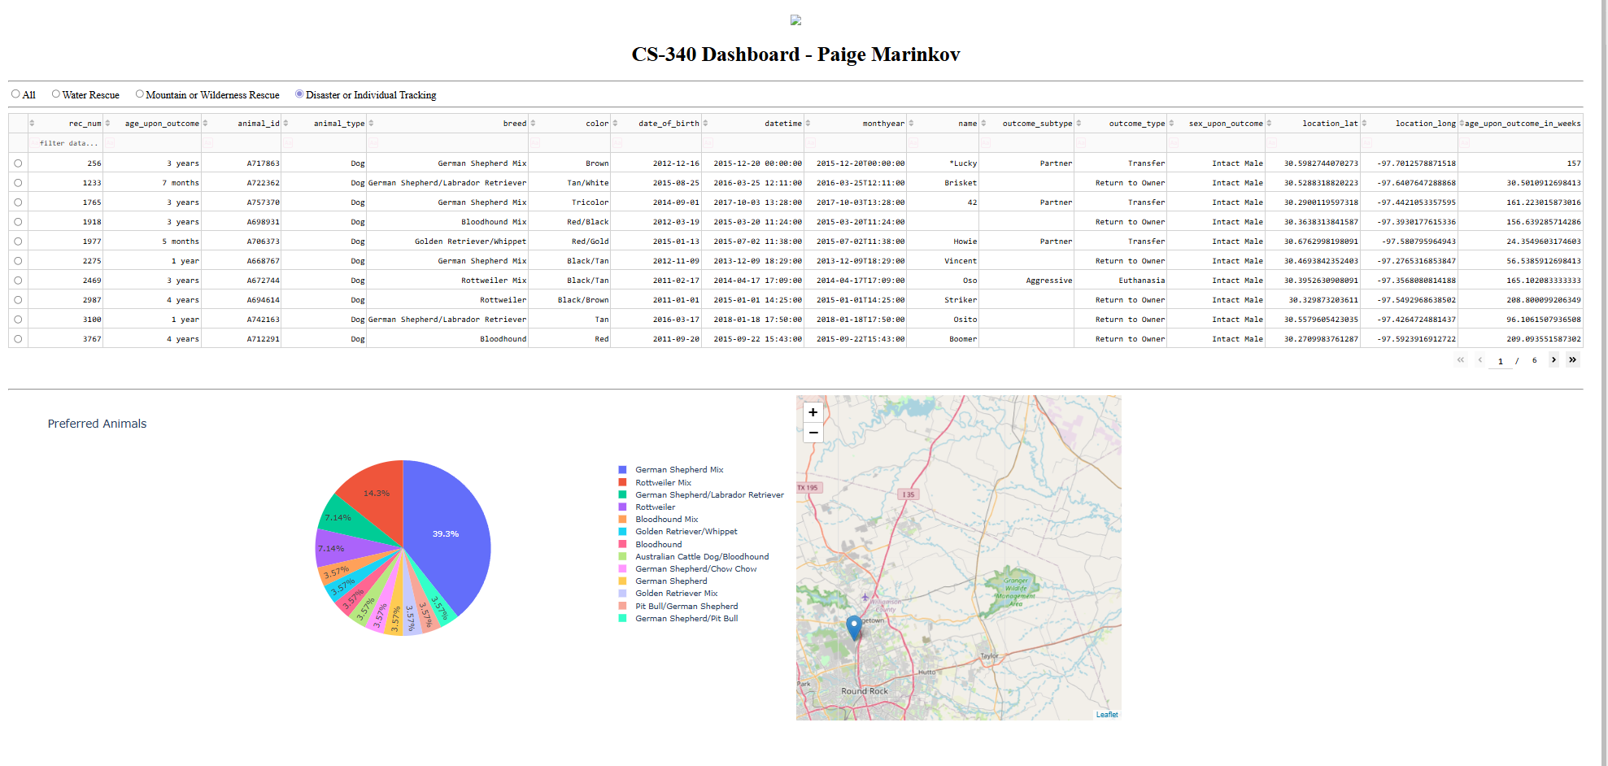

Figure 5: Reset to All Data
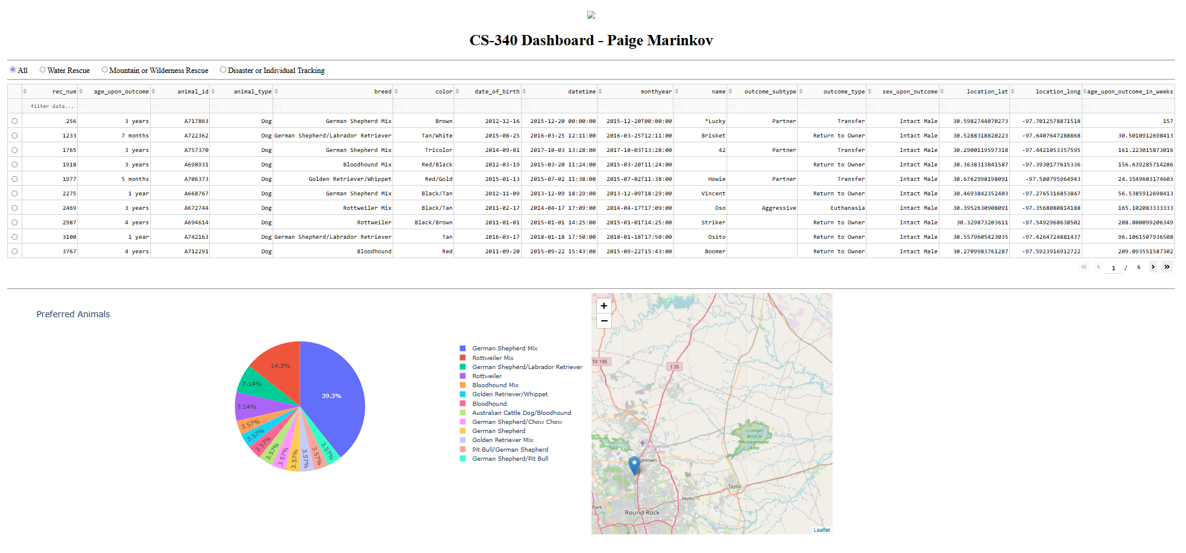

Tools and Technologies Used
Python
Used as the primary programming language to develop the dashboard and CRUD module.
MongoDBhttps://www.mongodb.com
Used as the database to store and manage animal shelter data.
PyMongo https://pymongo.readthedocs.io
Used to connect Python to MongoDB and perform CRUD operations.
Dash (Plotly) https://dash.plotly.com
Used to build the web-based dashboard interface, including interactive components and callbacks.
Dash Leaflet https://dash-leaflet.herokuapp.com
Used to implement the geolocation map.
Pandas https://pandas.pydata.org
Used for data manipulation and conversion between MongoDB data and dashboard components.
Rationale for Tools
MongoDB was chosen as the database because it is a NoSQL database that stores data in flexible, JSON-like documents. This makes it well-suited for handling large datasets like the Austin Animal Center data. It integrates easily with Python using PyMongo, allowing efficient data retrieval and manipulation.
The Dash framework was used because it allows developers to build interactive web applications entirely in Python without requiring knowledge of HTML, CSS, or JavaScript. Dash supports dynamic updates through callbacks, making it ideal for dashboards that respond to user input.
Steps Taken to Complete the Project
- Imported the Austin Animal Center dataset into MongoDB.
- Developed a CRUD Python module to interact with the database.
- Created a Jupyter Dash application to display data.
- Built an initial unfiltered data table.
- Developed MongoDB queries to filter data by rescue type.
- Implemented interactive filtering options using radio buttons.
- Connected filters to the data table using Dash callbacks.
- Added a pie chart to visualize breed distribution.
- Added a geolocation map to display animal locations.
- Tested the dashboard to ensure all components updated correctly.
- Captured screenshots demonstrating functionality.
- Documented the project in this README.
- Reproduction Instructions
To run this project, follow these steps:
Install required libraries:
- Python
- MongoDB
- PyMongo
- Dash
- Dash Leaflet
- Pandas
- Ensure MongoDB is running locally.
Import the dataset using:
mongoimport --db aac --collection animals --type csv --headerline --file aac_shelter_outcomes.csv
Ensure the database user credentials match:
username = "admin"
password = "Admin123!"
Open the file:
ProjectTwoDashboard.ipynb
Run all cells in the notebook.
The dashboard will launch at:
http://127.0.0.1:8050
Challenges Encountered
One major challenge was resolving authentication errors when connecting Python to MongoDB. This was caused by incorrect credentials and mismatched authentication databases. The issue was resolved by ensuring the correct username, password, and authSource='admin' were used consistently.
Another challenge involved fixing Dash callback errors and indentation issues, which prevented the dashboard from running. These were resolved by carefully structuring the callback functions and ensuring proper Python indentation.
Additionally, there were issues with the dashboard not displaying due to port conflicts. This was fixed by restarting the Jupyter environment and ensuring the correct port was used.
Conclusion
This project successfully demonstrates the integration of MongoDB with a Python-based web dashboard using Dash. The final product provides an interactive and user-friendly interface for filtering and visualizing animal rescue data, meeting all project requirements.

